About Experts

No Nonsense Approach
Non-Judgemental
Safe Space

MENTAL HEALTH PROFESSIONALS

Shivalika Srivastav
(Already added on the website)

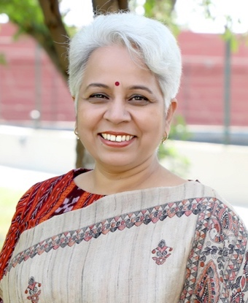
Jyoti Pande
Counselling Psychologist
20+ Years of Experience

Jyoti Pande is a happiness trainer, storyteller, and practising psychologist with an experience of more than 20 years and holds multiple degrees and diplomas from various reputed universities across India in the field of psychology. She is a certified trainer of happiness from the Institute of Child Education and Psychology (ICEP), Europe. She is also a happiness & mindfulness coach from the Berkley Institute of Well-Being and Happitude and is trained in mindfulness at the Mindfulness School, UK. Being the partner of an Army Officer, she has been working effortlessly in the welfare activities for the families of Army Personnel and has conducted Mental Health awareness programmes for more than 2000 families of Army Personnel. Having an anecdotist mind, Mrs Pande unfolded as one of the founding members of the Indian Storytellers Healing Network (ISHN). She has a diverse network under her space SOUL KATHA where she develops need-based programmes for various organisations, ranging from Storytelling to Mindfulness and the Science of happiness.


Arouba Kabir
Counselling Psychologist
8+ Years of Experience

Arouba Kabir is an MA in Counseling Psychology, Certified in Hypnotherapy - Sub Conscious Mind, CBT, Therapeutic Art, and Meditations. With an Exp. of 8 years in the Field, she has been proactively creating awareness about mental health, its importance, and significance via offline & online mediums for a decade. She works with individuals, couples, families, and corporates. Runs a setup, Enso Wellness where she focuses on holistic wellness. She has been awarded many times for her efforts in the Mental Health field and as a woman face in Entrepreneurship. She has successfully initiated and completed various online series, webinars, and workshops with eminent personalities and celebrities. Arouba's work has been appreciated and published by many known national And International publications. She is a daily writer for many national dailies like Indian Express, Hindustan Times, and many others.

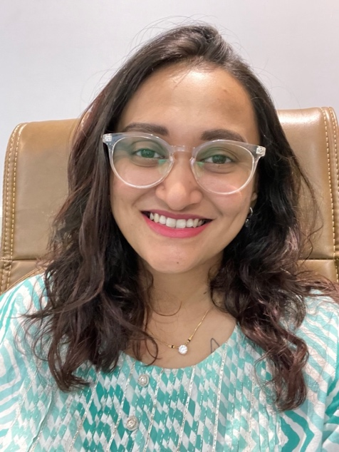
Dr Pritisha Saxena
Psychiatrist
5+ Years of Experience

Dr. Pritisha Saxena is a psychiatrist with more than 5 years of experience in the field of mental health wellness. She is the director and chief consultant at Vijaya Clinics based in Nagpur and has an association with Enso Wellness and Super you. Dr. Saxena has the expertise of diagnosing individuals having problems related to anxiety, depression, schizophrenia, ADHD, bipolar disorder, etc. She has completed her MBBS from Jawaharlal Nehru Medical College, Sawangi, and registered with Maharashtra Medical Council in 2018. Beyond their clinical work, she actively engages in mental health advocacy and community outreach.

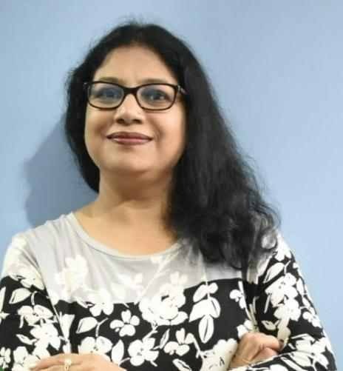
Preeti Khare
Counselling Psychologist
30+ Years of Experience

Preeti Khare is a Counselling psychologist, Professional Certified Coach recognized by the International Coach Federation (IFC-PCC), and founder of ENABLEance, which help couples to build and sustain their relationship. She has helped more than 5000 individuals by instructing and empowering them. Coach Khare is the president of a UK-based independent regulator, The Nursing and Midwifery Council, Coaching Support Group, Bhopal, and MP WICCI Coaching Council. She is an MBA (HR), MSA from Central Michigan University, USA.

WELLNESS EXPERTS


Gunjan Kamra
Celebrity Yoga Trainer
3+ Years of Experience

Gunjan Kamra is a certified celebrity yoga trainer having more than 3 years of experience in yoga, stress management and therapeutic healing. She has trained 40+ celebrities and influencers, including Mrunal Thakur, Kusha Kapila, Priya Mani, Rahul Subramanian and many more, for their holistic physical and mental well-being. Gunjan is an expert in conducting goal-oriented sessions for her clients. Through the power of Yoga, she helps people get fitter physically and emotionally and helps them live a harmonious, peaceful, and healthy life. Gunjan has catered to over 5000+ clients and 50+ corporates and helped them take care of their health issues and lead a happy life.

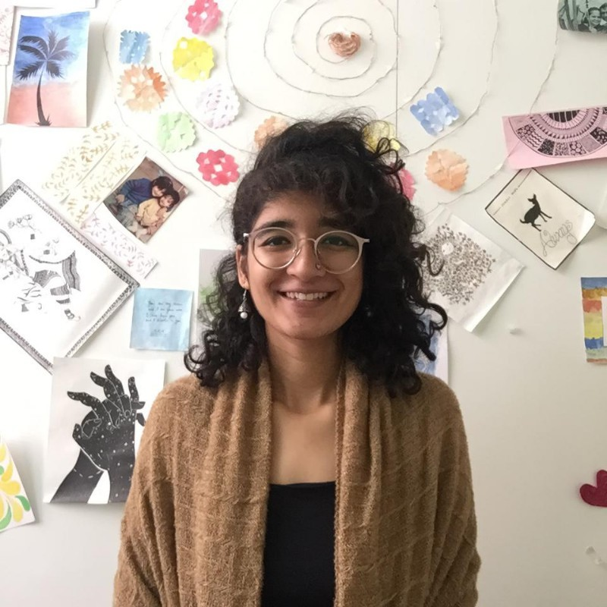
Shreyasi Walia
Spiritual Influencer

Shreyasi Walia is a spiritual influencer and teaches the art of meditation. She is a Chartered Accountant, a law graduate and a scriptwriter, currently working as an assistant director for various digital platforms. Ms Walia, in her social media platforms, humorously explain the benefits of meditation and titled her initiative ‘500 Reasons to Meditate’. For the past eight years, she had been practising meditation, and at the time of the lockdown, she decided to teach meditation online to aware society of the benefits of the same.


Riddhi Deorah
Parenting Coach

Riddhi Deorah is an entrepreneur, parenting coach, and the founder of Easy Parenting Hub, a platform for parents to live a happy, holistic, and spiritual life. She studied Economics at the University of Cambridge and the London School of Economics. She also writes a weekly parenting column for Dainik Jagran, Har Zindagi, conducts workshops for corporates globally, and is a panel speaker for various International Summits.

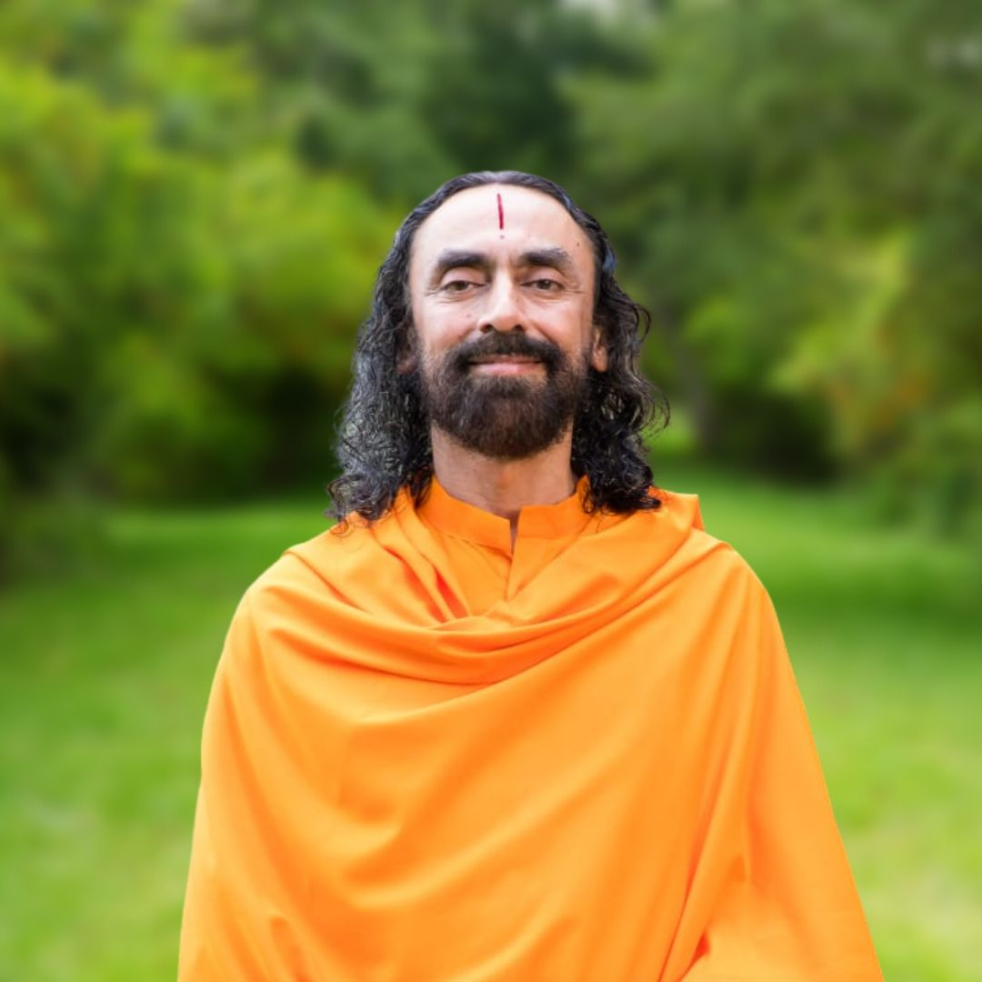
Swami Mukundananda
Spiritual Leader

Swami Mukundananda is a spiritual leader, author, and Vedic scholar. He is the founder of JKYog, an incorporation of Hatha Yoga and Bhakti Yoga. He graduated from IIT Delhi and IIM Calcutta and then, opted to follow the spiritual path. He has given philosophical and spiritual speeches at various institutions like Google, Oracle, United Nations, Stanford University, Princeton University, etc. He has appeared in various talk shows with Ranveer Allahbadia, Sandeep Maheshwari, and Boman Irani.

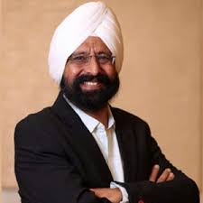
Dr Gurmeet S. Narang
Happiness Coach

Dr. Gurmeet S. Narang aka Man of Happiness, is an author, public figure, and happiness leader, has published a book titled Thode ki zaroorat hai (All you need is less) which explores the secrets of happiness in human life. He is the founder of India's only eternal happiness organization, Tavleen Foundation, which works in the area of contemplative studies for the overall betterment of life by achieving peaceful and mind solutions. Dr. Narang has written a total of 9 books on happiness to reduce the suffering of all the living beings of the world.

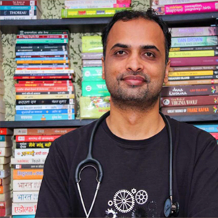
Dr Abrar Multani
Ayurveda and Hijama Practitioner

Dr. Abrar Multani is a bestselling author on health issues. He is a renowned physician in the nation who treat chronic and complicated cases with mastery through Ayurveda & Hijama. He founded Incredible Ayurveda which is one of the most successfully run Ayurveda Clinics in India and is situated in the capital of Madhya Pradesh, Bhopal. He is also the President of an NGO named Smiling Hearts which is truly devoted to the needy but poor people for their health, nutrition, and education. Dr. Abrar Multani is best known for his best-selling books Beemar Hona Bhul Jaiyye (Forget to be ill), Mann Keliye Amrit ki Bunde (Prescription of Thoughts), 5 Pills For Depression and Stress, Beemariya Harengi, Jeena Sikha Dengi, Motape se Breakup, Kyun alag hai stripurush ka prem (Join Happy Couples Club). He is also a columnist in leading newspapers and magazines of nation like Dainik Bhaskar, NBT, Patrika, India Today, Aha! Zindagi etc.


Aman Garewal
Life Coach

Aman Grewal is an entrepreneur, certified life and success coach, and master practitioner in Neuro-Linguistic Programming from the National Federation of NLP, USA. She has conducted workshops for numerous universities and colleges in India. Aman also won the crown of Mrs. India worldwide and was adjudicated in many fashion events and beauty pageants as a jury. She is, currently, the official mentor and pageant coach for several national-level pageants. She also owns a creative home decor brand Floraonwood.

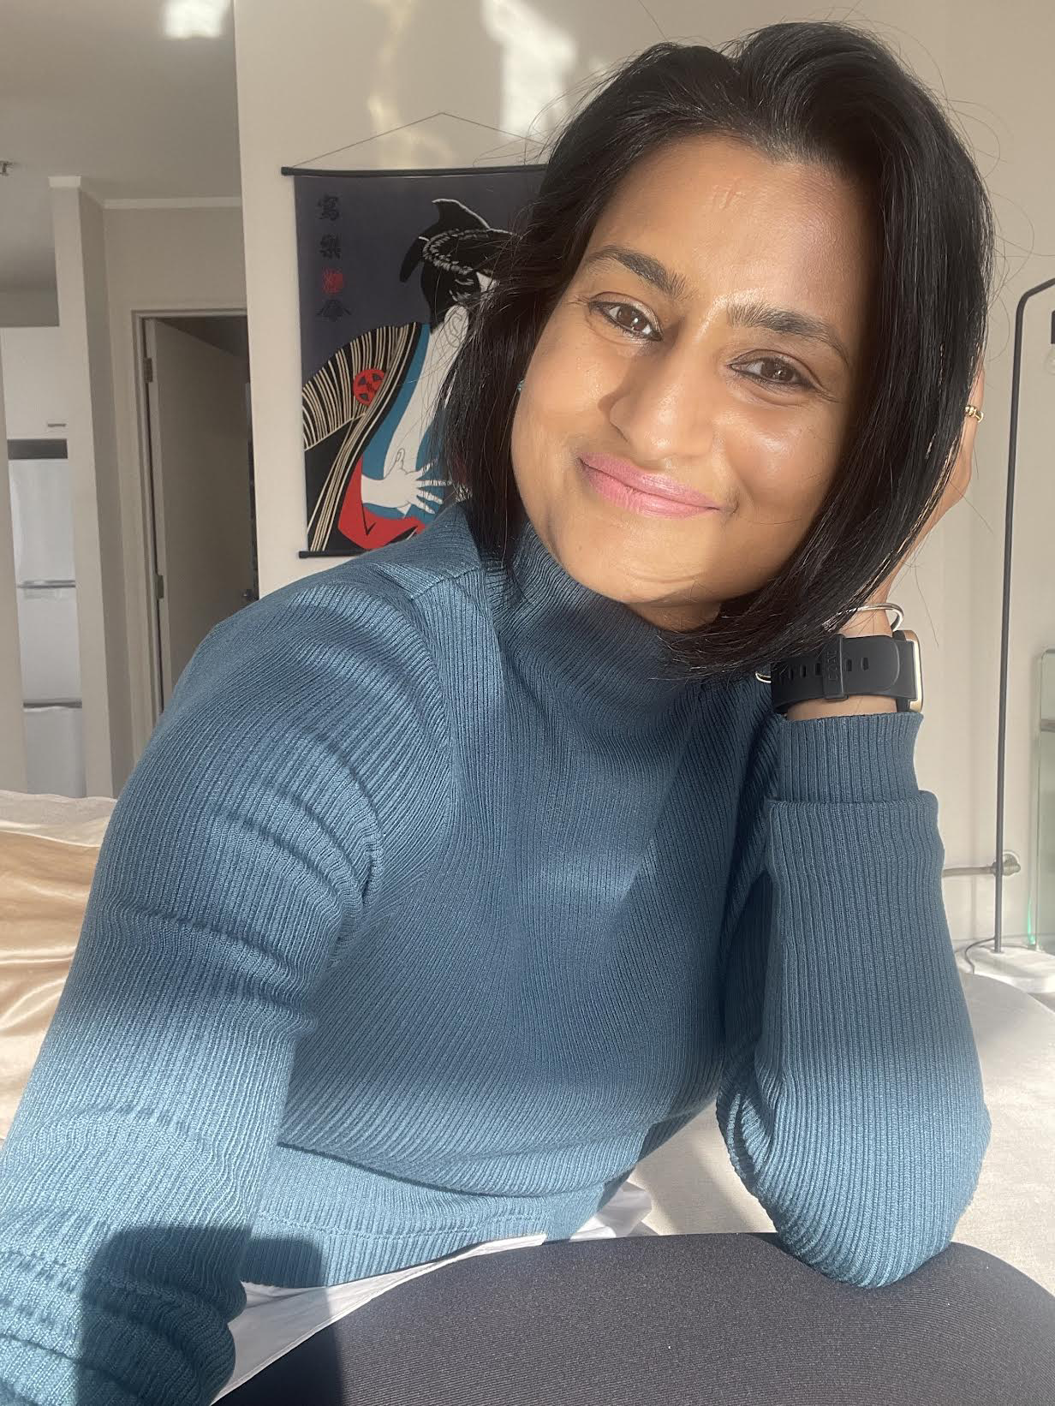
Rashmi Singh
Life Coach

Rashmi is a Certified Life Coach, Wellbeing Coach, Mindfulness Mentor, and Founder of The Mind Solace. By using techniques such as NLP, SMART goal setting, mindset training, positive self-talk, and more, she empowers her clients to overcome obstacles, discover their potential, and live fulfilling lives. She has conducted workshops to promote self-care and mindfulness for organizations, retreats, and wellness festivals. Rashmi's approach is rooted in empathy, self-compassion, and positive transformation. Her mission is to help you thrive, find balance, and become the best version of yourself. She has created The Mind Solace which works as your personalized procrastination smasher and guides you to live a life full of happiness and discipline. With years of experience in the field of wellness, she coaches people to understand their own unique needs and helps them to create a routine, ritual or practice that fits them best.

